Name:  Class: | ____________________________________  ________________ |  | Date:_________
 | Year 11 Essentials  Major Test Unit 1, 2020 |  | / 56  10%
Total Time: | 55 min TOTAL
Weighting: | 10 %
Equipment: | Calculator , Notes page

Question 1 4 marks

Convert the following units.

- 550 cm to m b) 76.4 mm to cm

- 16 cm² to mm² d) 176000 m² to km²

Question 2 2 marks

What unit of measurement would you use for measuring:

- the length of your desk?

- the length of the school oval?

Question 3 3 marks

- Peter has a 2.5 m length of wood that he cuts into five equal lengths. State the length of each piece in cm.

- If a length of timber is 1.2 m how many pieces of timber are needed to build a square frame that has a perimeter of 6 m?

Question 4 8 marks
Find the perimeter and area of the shapes below (round to 1 decimal place if necessary):

- 6cm b)
7.8 mm
3.3.mm
4 cm
6.9 mm

Question 6 6 marks
- Peter owns two blocks of land. One is 126 m by 92 m and the other is 177 m by 56 m. Which is the bigger block of land?

- He decides to fence the bigger block of land. How many metres of fence will there be?

- If fencing costs $12.50 per meter how much will it cost him to fence the bock?

Question 7 2 marks

Using the conversion 1 calorie = 4.2 kilojoules, convert the following:

- 600 calories = ___________ kilojoules

- 1500 kilojoules = ___________ calories

Question 8 4 marks

- Use the formula $v=u+at$ to find the value of $v$, when$u=5$ . $a = 4$ and $t=7$.

- The formula$C=\frac{5}{9}(F-32)$ is used to convert between temperatures in degrees Celsius ($C$) and degrees Fahrenheit (F). Find the Celsius equivalent of 50º Fahrenheit.

Question 9 3 marks

After exercising, John counted his pulse rate as 15 beats per 10 seconds.
- What is John’s pulse rate in beats per minute?

- John was exercising with Michael who counted his pulse rate as 35 beats per 25 seconds. Who has the lower pulse rate? Show working.

Question 10 2 marks
The pictograph shows how many glasses of water six students drank in a week.
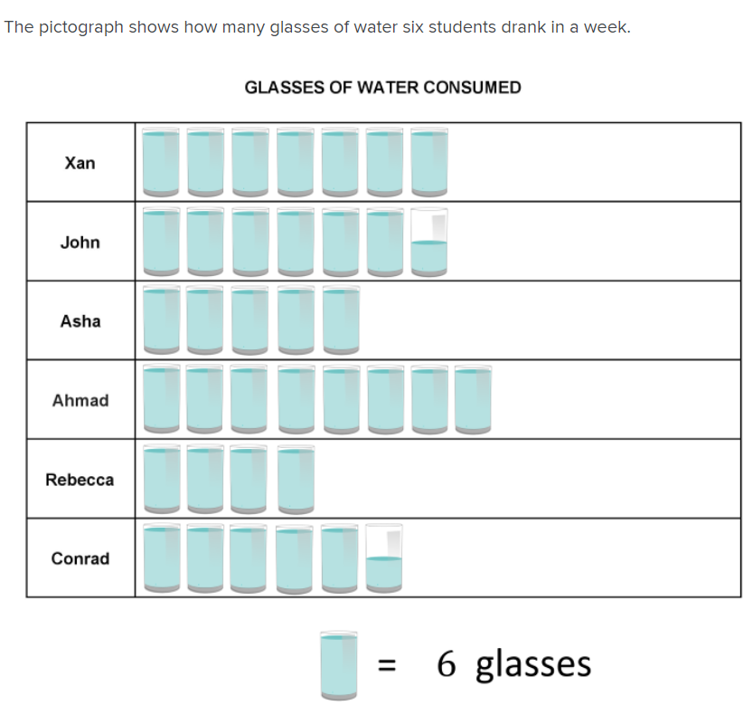

- How many glasses did Rebecca drink?

- John drank how many more glasses than Asha?

Question 11 6 marks

30 children were asked which sport they preferred basketball or soccer . Their results are recorded in the table below.
 | Basketball | Soccer | Total
Girls | 12 |  | 18
Boys |  | 7
Total

- Complete the missing values

- How many girls prefer soccer?

- What percentage of children preferred soccer?

- What percentage of boys preferred basketball?

Question 12 5 marks

The graph below shows the mean temperatures and rainfall over a year for Perth.
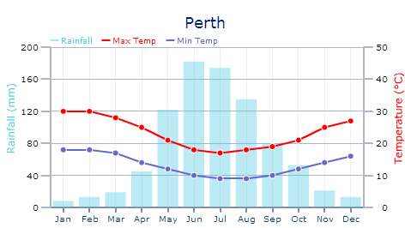
- What is the mean maximum temperature in September?

- Which month has the coldest mean minimum temperature?

- What is the difference between the mean maximum and mean minimum temperatures in September?

- How much more rain falls in June than December?

- Describe the annual rainfall pattern?

Question 13 2 marks

Convert the following:

- 0.3m³ to cm³ b) 126mm³ to cm³

Question 14 2 marks

A carton of soft drink contains 24 cans. Each can holds 375mL. How many litres are there in the carton?

10cm
Question 15 4 marks

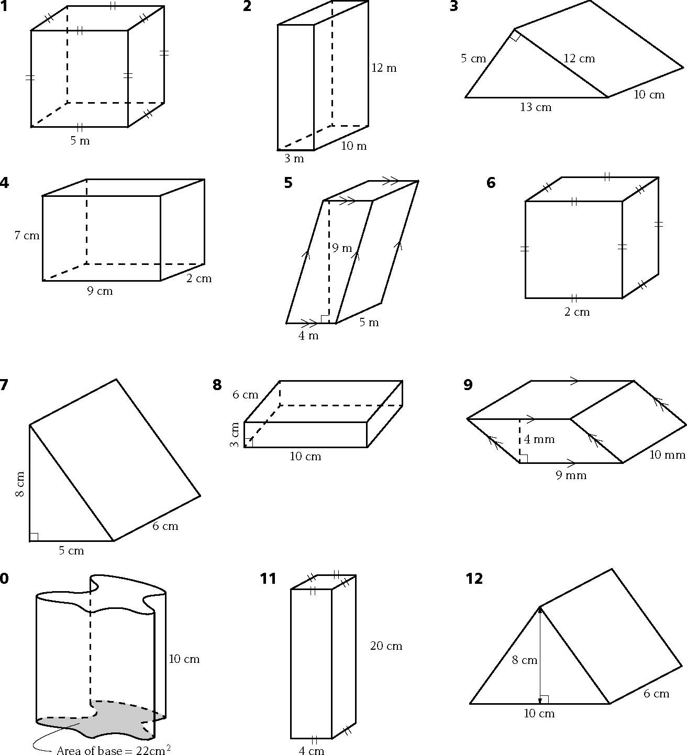
Calculate the volume of each prism below.
a)

b)
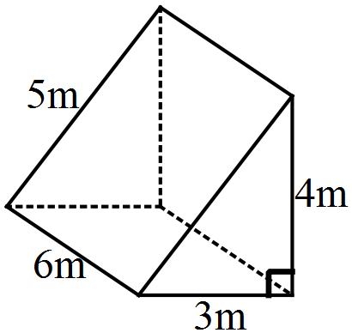

Question 16 3 marks

In times of drought some farmers need to purchase drinking water. Farmer Jack needs to buy water weekly and he does so in a tank in the shape of a rectangular prism. The tanks dimensions are 2m by 1·5m by 1m.
Calculate the capacity of the tank.

End of Test

